Group members

M Ntshangase 22341705

S B Dladla 22303354

CK Kunene 22324272

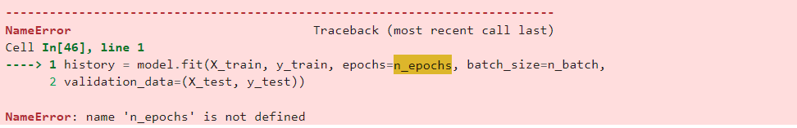  
  
**---------------------------------------------------------------------------**

**ValueError** Traceback (most recent call last)

Cell **In[44], line 1**

**----> 1** model.add(Dense(1))

File **~\AppData\Local\Packages\PythonSoftwareFoundation.Python.3.12_qbz5n2kfra8p0\LocalCache\local-packages\Python312\site-packages\keras\src\models\sequential.py:121**, in Sequential.add**(self, layer, rebuild)**

119 self._layers.append(layer)

120 **if** rebuild:

**--> 121** self._maybe_rebuild()

122 **else**:

123 self.built = **False**

File **~\AppData\Local\Packages\PythonSoftwareFoundation.Python.3.12_qbz5n2kfra8p0\LocalCache\local-packages\Python312\site-packages\keras\src\models\sequential.py:140**, in Sequential._maybe_rebuild**(self)**

138 **if** isinstance(self._layers[0], InputLayer) **and** len(self._layers) > 1:

139 input_shape = self._layers[0].batch_shape

**--> 140** self.build(input_shape)

141 **elif** hasattr(self._layers[0], "input_shape") **and** len(self._layers) > 1:

142 # We can build the Sequential model if the first layer has the

143 # `input_shape` property. This is most commonly found in Functional

144 # model.

145 input_shape = self._layers[0].input_shape

File **~\AppData\Local\Packages\PythonSoftwareFoundation.Python.3.12_qbz5n2kfra8p0\LocalCache\local-packages\Python312\site-packages\keras\src\layers\layer.py:226**, in Layer.__new__.<locals>.build_wrapper**(*args, **kwargs)**

224 **with** obj._open_name_scope():

225 obj._path = current_path()

**--> 226** original_build_method(*args, **kwargs)

227 # Record build config.

228 signature = inspect.signature(original_build_method)

File **~\AppData\Local\Packages\PythonSoftwareFoundation.Python.3.12_qbz5n2kfra8p0\LocalCache\local-packages\Python312\site-packages\keras\src\models\sequential.py:186**, in Sequential.build**(self, input_shape)**

184 **for** layer **in** self._layers[1:]:

185 **try**:

**--> 186** x = layer(x)

187 **except** **NotImplementedError**:

188 # Can happen if shape inference is not implemented.

189 # TODO: consider reverting inbound nodes on layers processed.

190 **return**

File **~\AppData\Local\Packages\PythonSoftwareFoundation.Python.3.12_qbz5n2kfra8p0\LocalCache\local-packages\Python312\site-packages\keras\src\utils\traceback_utils.py:122**, in filter_traceback.<locals>.error_handler**(*args, **kwargs)**

119 filtered_tb = _process_traceback_frames(e.__traceback__)

120 # To get the full stack trace, call:

121 # `keras.config.disable_traceback_filtering()`

**--> 122** **raise** e.with_traceback(filtered_tb) **from** **None**

123 **finally**:

124 **del** filtered_tb

File **~\AppData\Local\Packages\PythonSoftwareFoundation.Python.3.12_qbz5n2kfra8p0\LocalCache\local-packages\Python312\site-packages\keras\src\layers\input_spec.py:186**, in assert_input_compatibility**(input_spec, inputs, layer_name)**

184 **if** spec.ndim **is** **not** **None** **and** **not** spec.allow_last_axis_squeeze:

185 **if** ndim != spec.ndim:

**--> 186** **raise** **ValueError**(

187 f'Input **{**input_index**}** of layer "**{**layer_name**}**" '

188 "is incompatible with the layer: "

189 f"expected ndim=**{**spec.ndim**}**, found ndim=**{**ndim**}**. "

190 f"Full shape received: **{**shape**}**"

191 )

192 **if** spec.max_ndim **is** **not** **None**:

193 **if** ndim **is** **not** **None** **and** ndim > spec.max_ndim:

**ValueError**: Input 0 of layer "lstm_1" is incompatible with the layer: expected ndim=3, found ndim=2. Full shape received: (None, 50)

**---------------------------------------------------------------------------**

**NameError** Traceback (most recent call last)

Cell **In[46], line 1**

**----> 1** history = model.fit(X_train, y_train, epochs=n_epochs, batch_size=n_batch,

2 validation_data=(X_test, y_test))

**NameError**: name 'n_epochs' is not defined

**---------------------------------------------------------------------------**

**NameError** Traceback (most recent call last)

Cell **In[47], line 1**

**----> 1** prediction = model.predict(X_test)

**NameError**: name 'X_test' is not defined